**Direct Titration Calculations**

**Example Titration**

A student used a standard solution of NaOH in a titration to determine the concentration of ethanoic acid in a sample of vinegar.

**Data measured:**

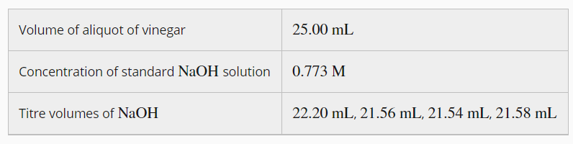

The concentration of the vinegar can be calculated using the following steps

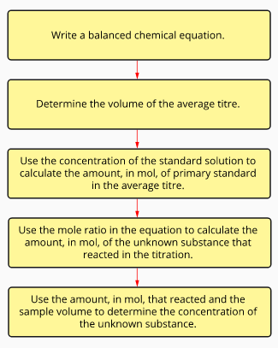

**Calculation Summary**

**Calculate the number of moles of the standard solution**

**n = m/M**

**Use stoichiometry, to determine the number of moles of unknown.**

**Calculate the concentration of the unknown**

**c = n / V**

* When determining average titre on concordant titres (those that differ by less than 0.1 mL) are included

**In this titration**



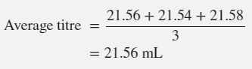

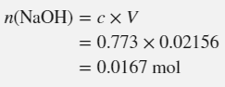



To convert mL to L is to multiply the mL by 10-3

For example:

16.00 mL= 16.00 x 10-3 = 0.016 mL

25.0 mL = 25.0 x 10-3 L = 0.025 mL

You can either use the scientific notation version directly in your calculation, or if you prefer, enter it in your calculator (then press =) to convert it to a decimal value.

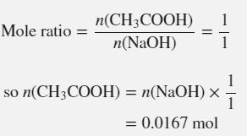

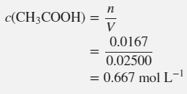

**Try This Question**

20.00 mL aliquots of hydrochloric acid are titrated with 9.039 x 102 mol L-1 sodium carbonate solution. Several titrations were performed and the volumes of sodium carbonate solution were 19.45 mL, 18.90 mL, 18.77 mL, and 18.85 mL. What is the concentration of the hydrochloric acid solution?

(Answer 1.703 x 10-1 mol L-1)

**Titration calculations involving dilution**

If the solution to be tested was diluted at the start, the concentration of the diluted solution can be determined as above. Then the concentration of the original solution is determined by multiplying the diluted concentration by the dilution factor.

**dilution factor = original volume / final volume**

**original concentration = diluted concentration x dilution factor**

**Example Titration**

A commercial concrete cleaner contains hydrochloric acid. A 20.00 mL volume of cleaner was diluted to 250.0 mL in a volumetric flask. A 20.00 mL aliquot of 0.4480 M sodium carbonate solution was placed in a conical flask. Methyl orange indicator was added and the solution was titrated with the diluted cleaner. The indicator changed permanently from yellow to pink when 24.80 mL of the cleaner was added.

Calculate the concentration of hydrochloric acid in the concrete cleaner.

Step 1, calculate the concertation of the diluted HCl.

2HCl(aq) + Na2CO3(aq) → 2NaCl(aq) + H2O(l) + CO2(g)

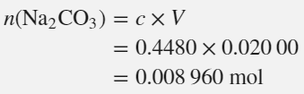

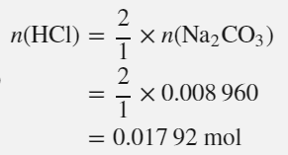

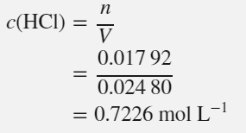

Step 2, apply the dilution factor to calculated the undiluted HCl concentration.

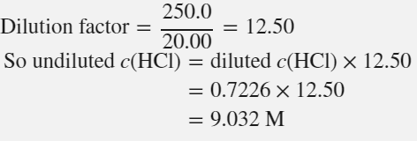

**Try This Question**

Commercial hydrochloric acid has a maximum concentration of around 12 mol L-1. A laboratory technician needed to accurately confirm the concentration of a batch of commercial hydrochloric acid. In order to do so a 15.00 mL sample of the acid is transferred to a 2.500 L volumetric flask and made up to the mark with distilled water.

20.00 mL samples of the diluted acid, HCl(aq), required on average 16.65 mL of 9.08 x 10-2 L NaOH(aq) for equivalence. Determine the concentration of the HCl(aq) in the commercial solution.

(Answer 12.6 mol L-1)

Answers

20.00 mL aliquots of hydrochloric acid are titrated with 9.039 x 102 mol L-1 sodium carbonate solution. Several titrations were performed and the volumes of sodium carbonate solution were 19.45 mL, 18.90 mL, 18.77 mL, and 18.85 mL. What is the concentration of the hydrochloric acid solution?

2HCl(aq) + Na2CO3(aq) 🡪 2NaCl(aq) + CO2(g) + H2O(l)

average titre = (18.90 + 18.77 + 18.85) / 3 = 18.84 mL (NB 19.45 is not a concordant titre)

n(NaCO3) = cV = 9.039 x 10-2 x18.84 x 10-3 = 1.7029 x 10-3 mol

n(HCL) = 2/1 x n(NaCO3) = 2 x 1.7029 x 10-3 = 3.4058 x 10-3 mol

c(HCl) = n/V = 3.4058 x 10-3 / (20.00 x 10-3) = 0.17029 = 1.703 x 10-1 mol L-1 (4 significant figures)

Commercial hydrochloric acid has a maximum concentration of around 12 mol L-1. A laboratory technician needed to accurately confirm the concentration of a batch of commercial hydrochloric acid. In order to do so a 15.00 mL sample of the acid is transferred to a 2.500 L volumetric flask and made up to the mark with distilled water.

20.00 mL samples of the diluted acid, HCl(aq), required on average 16.65 mL of 9.08 x 10-2 L NaOH(aq) for equivalence. Determine the concentration of the HCl(aq) in the commercial solution.

HCl(aq) + NaOH(aq) 🡪 NaCl(aq) + H2O(l)

n(NaOH) = cV = 9.08 x 10-2 x 16.65 x 10-3 = 1.512 x 10-3 mol L-1

n(HCl diluted) = n(NaOH) = 1.512 x 10-3 mol L-1

c(HCL diluted) = n/V = 1.512 x 10-3 / (20.00 x 10-3) = 7.560 x 10-2 mol L-1

c(HCl undiluted) = c(HCl) diluted x dilution factor

= 7.560 x 10-2 x 2.500 / (15.00 x 10-3)

= 12.6 mol L-1 (3 sig fig)